Supporting Information

Soil Fungal Communities Investigated by Metabarcoding within Simulated Forensic Burial Contexts

Table of Contents

Supporting figures

Figure S1. Abundances of OTUs groups after rarefaction and divided per kingdoms for Library A and B.

Figure S2. Rarefaction curves and species richness per each sample for Library A and B.

Figure S3. Alpha diversity indices per sample for Library A and B.

Figure S4. Regression lines for Shannon-Wiener alpha diversity measures for Library A and B.

Figure S5. Procrustes analysis showing the ordination of the samples according to their NMDS plots both for Library A and B.

Figure S6. Phyla abundances obtained overall in the experiment for Library A and B.

Figure S7. Shifts in the basal communities statistically significant between the control and P1 for Library B.

Figure S8. Shifts in the basal communities statistically significant between the control and P2 for Library B.

Figure S9. Shifts in the basal communities statistically significant between the control and P3 for Library B.

Figure S10. Shifts in the basal communities statistically significant between the control and P4 for Library B.

Supporting data

Table S1. Kingdoms obtained in Library A and B before refinement.

Table S2. Sequences of tags and list of the tags used for the amplification of ITS1 and ITS2 for each sample.

Table S3. OTU table with counts of the reads and taxonomic allocations after the filtering and the rarefaction processes for Library A (first sheet) and B (second sheet).
Table S4. Statistical analyses showing shifts in the overall communities at different PMIs comparing control soil (C1) versus gravesoils (P1, P2, P3 and P4) for Library A and B.
Table S5. OTU table with counts of the reads and taxonomic allocation of OTUs uniquely present in the basal fungobiome for Library A and B.
Table S6. OTU table with counts of the reads and taxonomic allocations of OTUs characteristic of the gravesoil for Library A and B.
Table S7. Multilevel pattern analysis showing species that significantly characterised the basal microbiome and the gravesoils.
Table S8. Statistical analyses showing shifts in the basal communities at different PMIs comparing control soil (C1) versus gravesoils (P1, P2, P3 and P4) for Library A and B.

Figure S1 – Number of rarefied reads grouped per kingdoms identified in Library A (top) and B (bottom) before the filtration step.
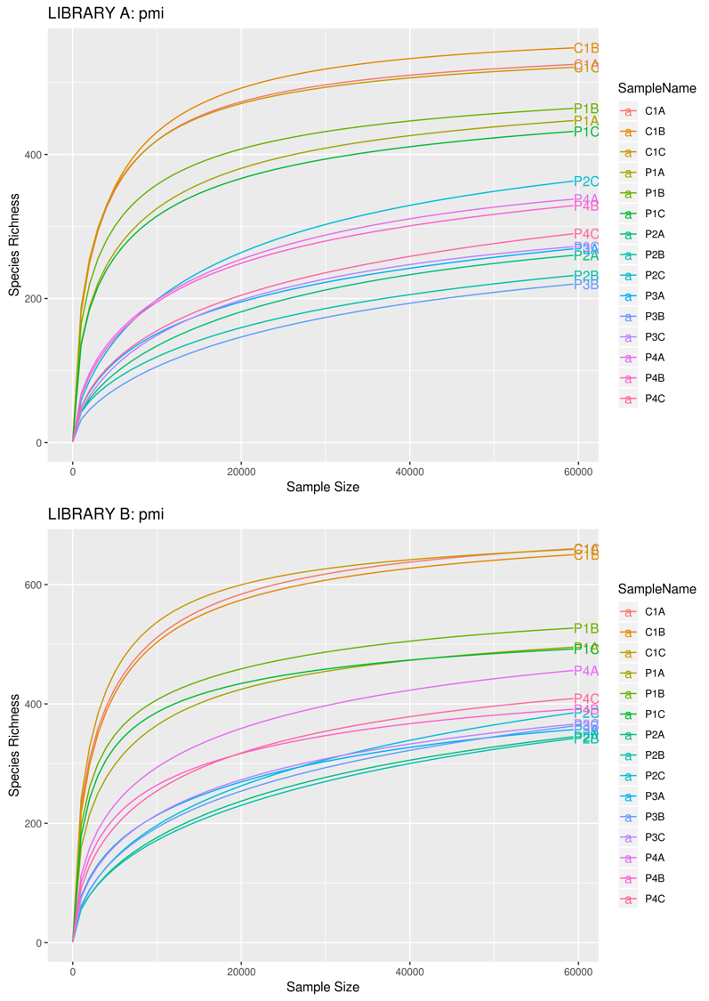
Figure S2 - Rarefaction curves with estimation of the species richness per sample for Library A (top) and B (bottom).

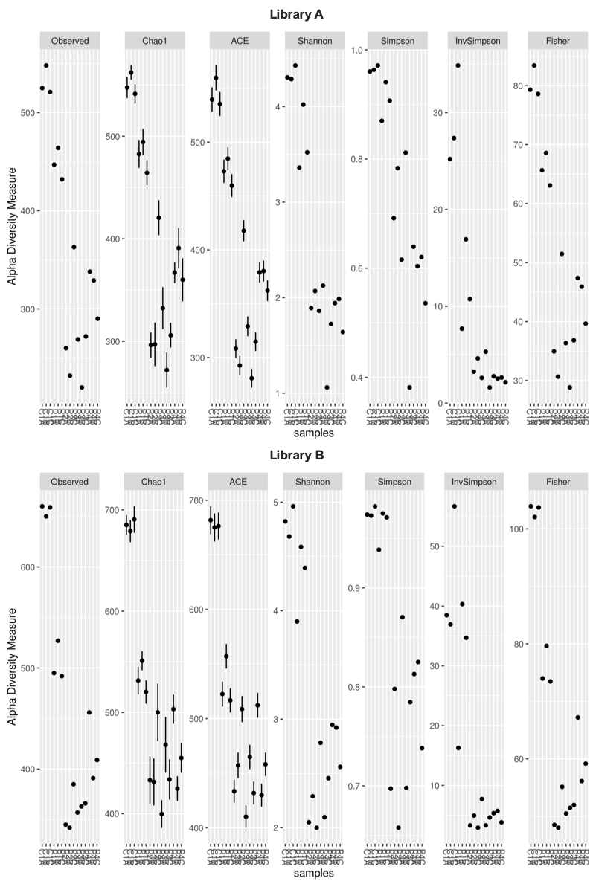

Figure S3 - Alpha diversity indices per sample evaluated in the study, including the observed species, Chao
1 index, ACE (abundance-based coverage estimators) index, Shannon index, Simpson and inverse Simpson
indices and Fisher index for Library A (top) and B (bottom).

Figure S4 - Regression lines for Shannon-Wiener alpha diversity measures for Library A (red) and Library B (blue), and adjusted R2 and p values for both regression lines.

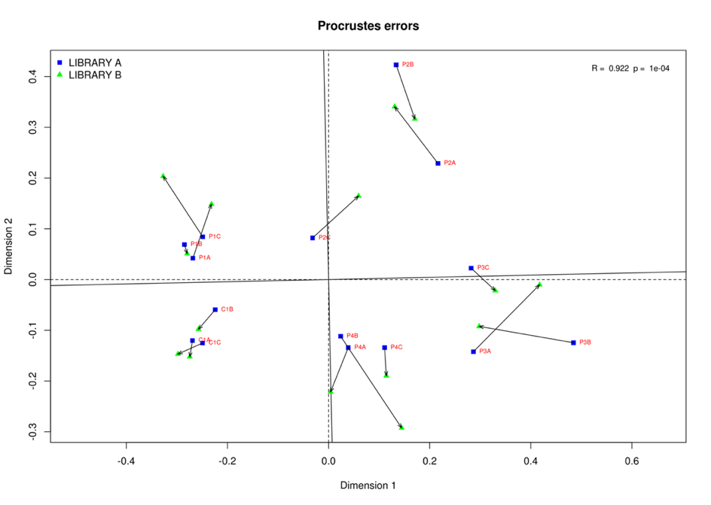
Figure S5 - Procrustes analysis showing the ordination of the samples according to their NMDS plots both for Library A (blue) and B (green). The same samples are connected by vector arrows (non-metric multidimensional scaling ordinations of Bray-Curtis distances). Vector length reflects the change in ordination space between the two libraries, and each of them points from the position of the samples in Library A towards their position in the Library B.

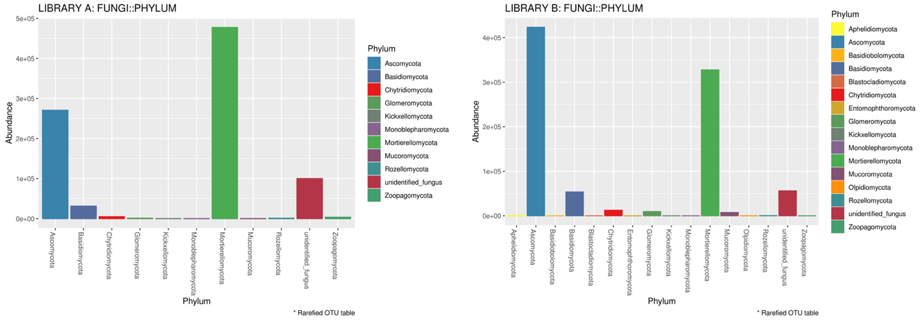

Figure S6 - Phyla abundances recorded overall in the experiment for Library A (left) and B (right).

Figure S7 - Shifts in the average abundances of the basal communities that were statistically significant between the control (C1) and the gravesoil collected after one-month PMI (P1) in Library B.

Figure S8 - Shifts in the average abundances of the basal communities that were statistically significant between the control (C1) and the gravesoil collected after two-months PMI (P2) in Library B.

Figure S9 - Shifts in the average abundances of the basal communities that were statistically significant between the control (C1) and the gravesoil collected after four-months PMI (P3) in Library B.

Figure S10 - Shifts in the average abundances of the basal communities that were statistically significant between the control (C1) and the gravesoil collected after six-months PMI (P4) in Library B.

